Sr.no | NAME | DESCRIPTION | PHOTO
1 | perimeter | Priestly smith S/LP,984 B&T  Make-Dolphin | 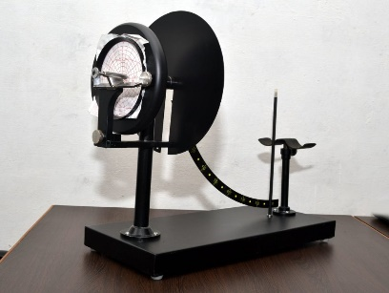
2 | kymograph | Sherrington starling electrically driven | 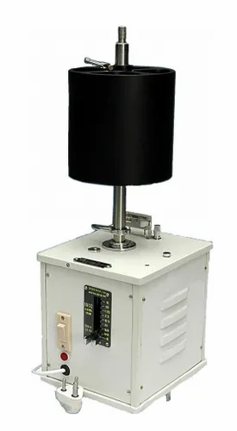
3 | Mosso’s ergograph | Make -dolphin | 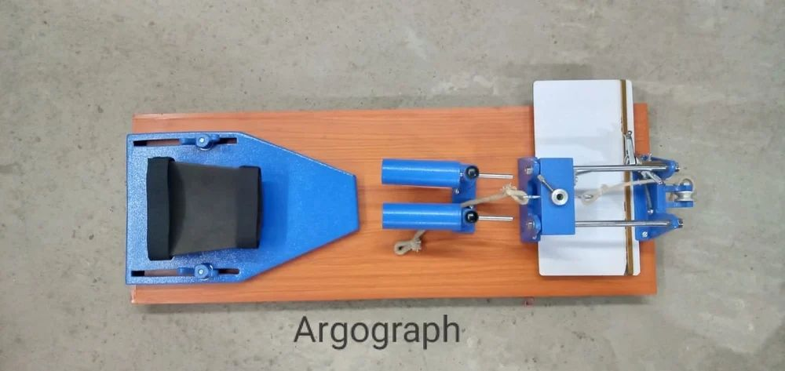
4 | Compass asthesiometer |  | 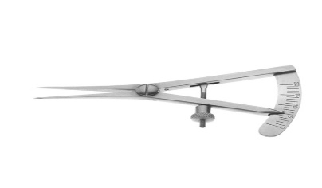
5 | Thermos asthesiometer |  | 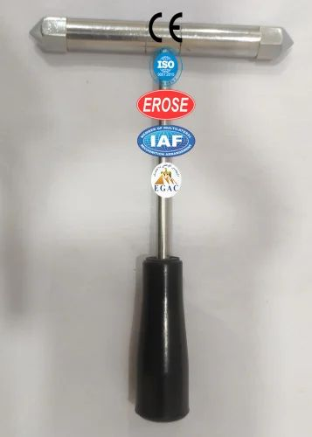
6 | algometer |  | 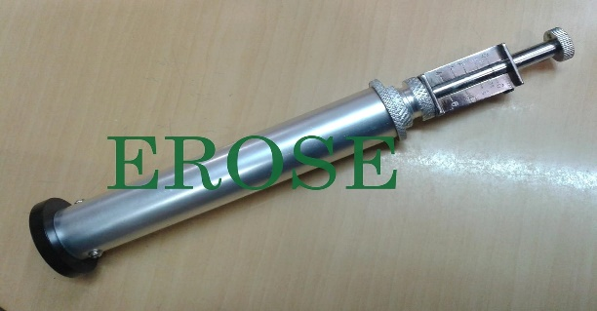
7 | Knee hammer |  | 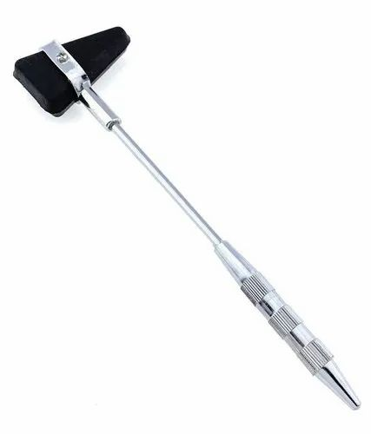
8 | Stethograph |  | 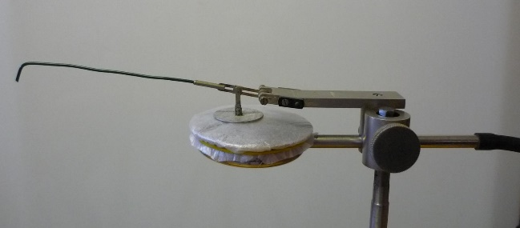  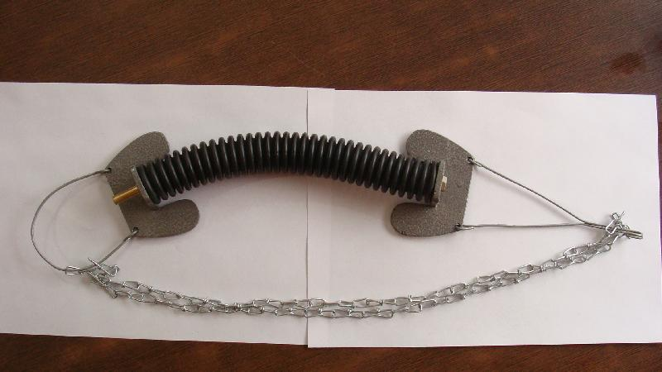
9 | Colorimeter, photoelectric |  | 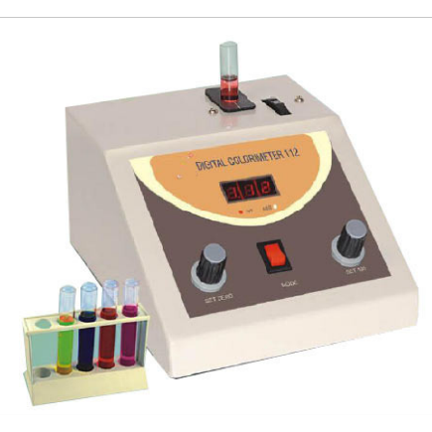
10 | Myograph stand |  | 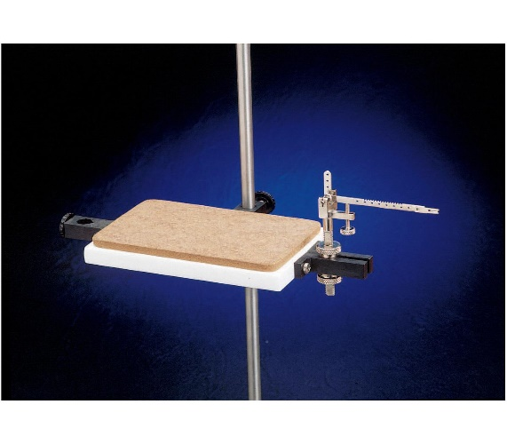
11 | Ph meter electric |  | 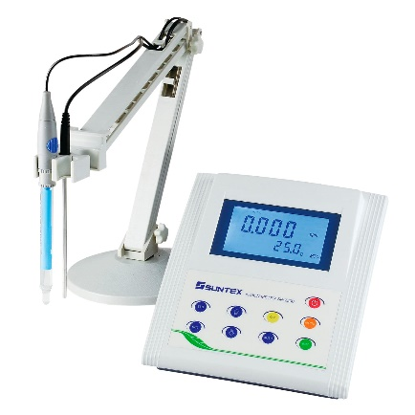
12 | Digital physiograph |  | 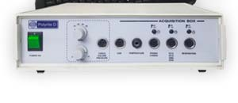
13 | Double demonstration eye peice |  | 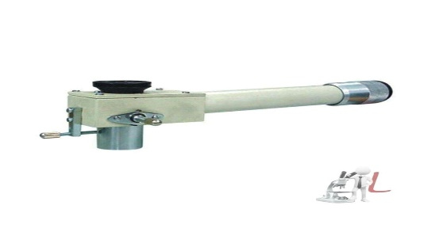
14 | Demonstration eye piece
15 | Tuning fork for hearing test 32-10000cps (sets 100,128,256,512 . | 100 hz | 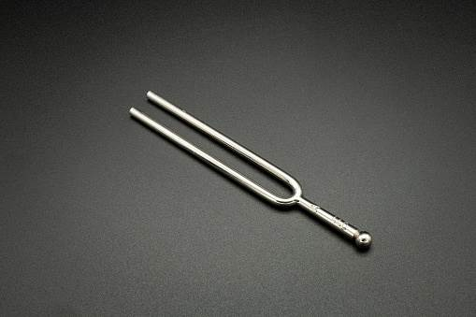
16 | Tuning fork for hearing test 32-10000cps (sets 100,128,256,512 . | 128 hz
17 | Tuning fork for hearing test 32-10000cps (sets 100,128,256,512 . | 256 hz
18 | Tuning fork for hearing test 32-10000cps (sets 100,128,256,512 . | 512 hz  1024 hz
19 | Centrifuge |  | 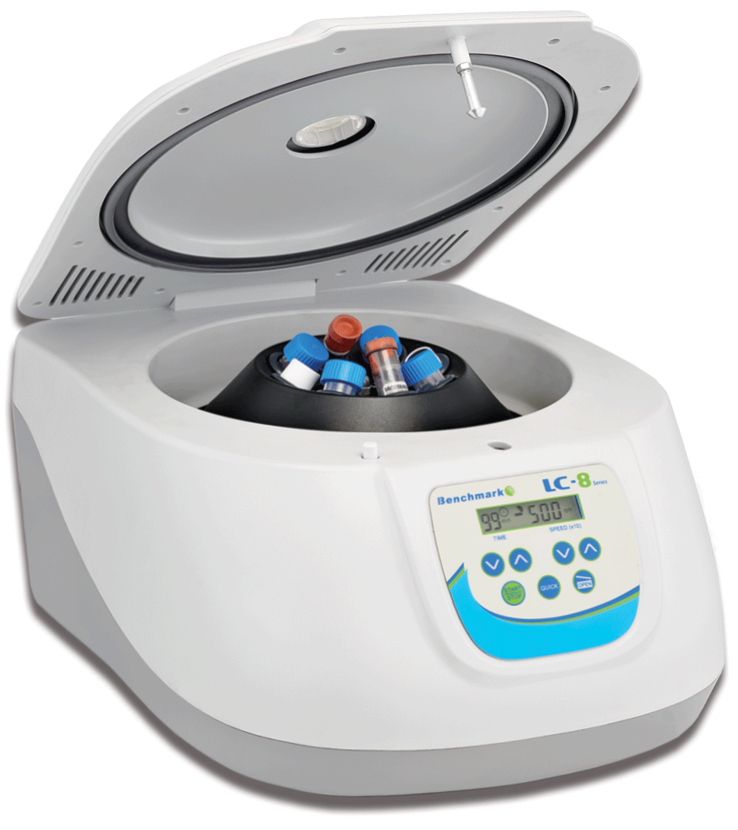
20 | Opthalomoscope |  | 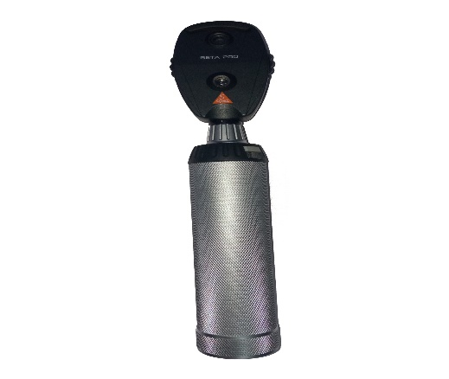
21 | Schematic eye
22 | phakoscope |  | 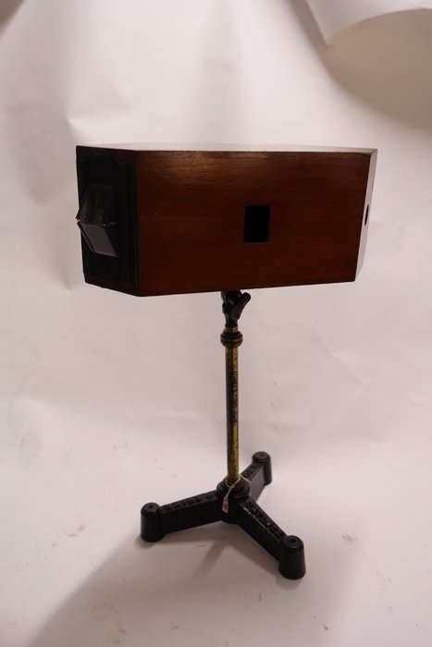
23 | Maddox rod |  | 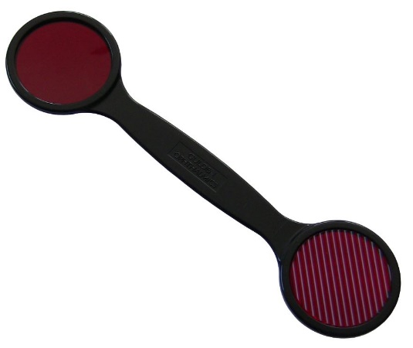
24 | Edridge green lantern |  | 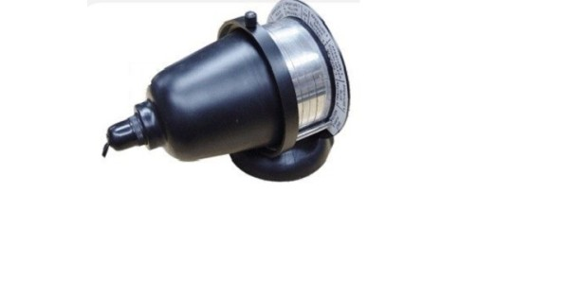
25 | Newton colour wheel |  | 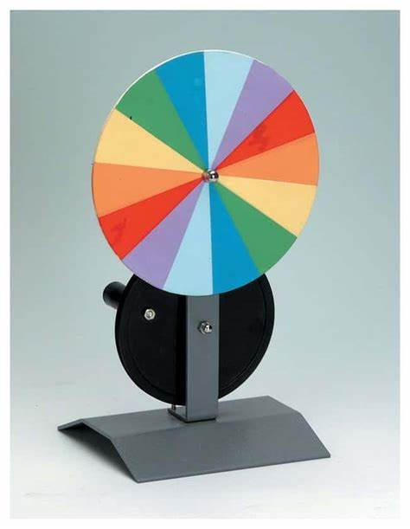
26 | dynamometer |  | 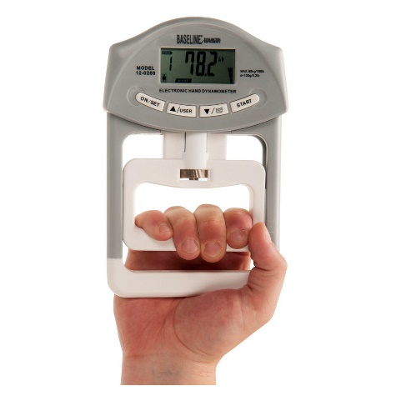
27 | Harward step test |  | 

