LYCHEE PLANT
SK NURSARY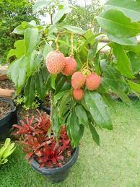

CONTACT FOR BULK ORDER
WHATAPP-8389971255
CALL-9800624704

